SOUTH DAKOTA ACADEMY OF SCIENCE

Annual Meeting, April 16-18, 2020
Northern State University, Aberdeen, SD

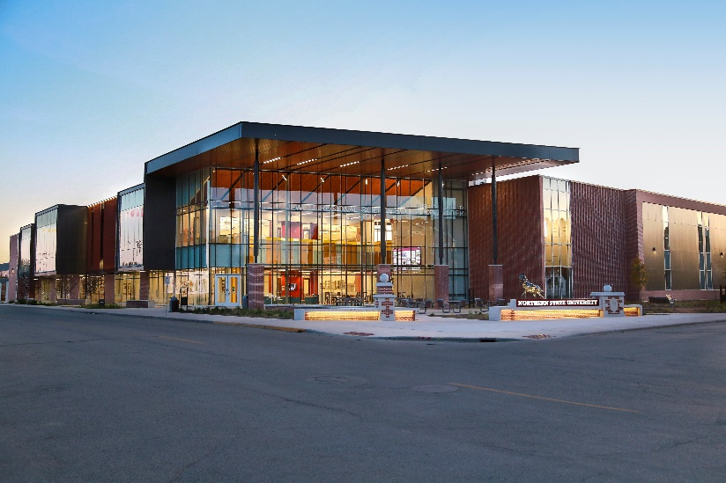
(www.northern.edu)

Scientists, Students and Educators- Present a poster or oral presentation of your research and meet others in your field.

Submit an abstract of your abstract by March 15, 2020.
Early bird registration for meeting ends March 15 also.

Details at http://www.sdaos.org

Symposium on Biofilms- Keynote Speaker
Clay Fuqua, Indiana University
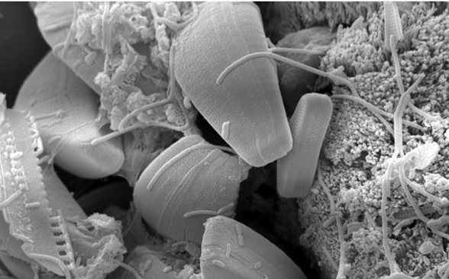
(D. Bermann and K. Moller)
See you there!

Undergraduate and Graduate Students

Your oral presentation or poster may be included in an oral presentation or poster judging competition and be awarded a monetary prize sponsored. First prize = $300; Second prize = $200; Third prize = $100. Oral presentations are scheduled for Saturday morning and posters for Saturday afternoon. Past first place winners are not eligible to compete. See the Proceedings Submission Form (below) to indicate your desire to be included in the judging. See www.sdaos.org for competition guidelines.

Authors presenting papers and/or posters must submit their abstracts and Proceedings Submission Form by March 15, 2020. The author or one co-author must be a member of the South Dakota Academy of Science and register to present at the annual meeting, paying all applicable fees and membership dues. In addition to new submissions, all posters and oral presentations listed in the 2019 Annual Meeting Program may be resubmitted for presentation in 2020; however, only those not published in 2019 may be considered for publication in the 2020 Proceedings.
To pre-register, please download, complete and mail the Registration Form (see below). Early bird registration ends March 15, 2020. For additional information, including membership, visit the SDAS Web Site at http://sdaos.org

Tentative Meeting Schedule
Thursday, April 16 | Friday, April 17 | Saturday, April 18
 | 11:00 am Registration | 7:30 am Registration
 | NOON Lunch | 8:00 am Oral Presentation Sessions
 | 1:00 pm Fellows Symposium | 10:00 am Poster Presentations
 | 3:00 pm Biofilms Symposium | NOON Lunch
 | 5:00 pm Mixer | 1:00 pm Business Meeting
6:00 pm Dinner and Executive meeting | 6:00 pm Banquet | 2:00 pm Oral Presentation Sessions
 | 7:00 pm Keynote Address
Motel Accommodations
Steele Hall on NSU Campus - $26+tax
- Dorm style set up with linens
- Single occupancy with private shower
- Double occupancy with in-suite shower
- Free Wi-fi access
- Couch, mini fridge, microwave
- Call Kami 605-626-2517 to reserve – Pay cash or check when arrive

Super 8 East: 605-824-6422 (State Rate $75+tax, block of rooms held until March 17th)
Best Western Ramkota: 605-229-4040 (Direct Billed needed for State Rate $77, block of rooms held until March 17th)
Hampton Inn and Suites: 605-262-2600 ($96 Gov Rate offered)
TownePlace Suites by Marriott: 605-725-3500 ($96 Gov Rate offered)
Holiday Inn Express: 605-725-4000 ($124 Gov Rate offered)
AmericInn: 605-225-4565

For state rates see http://www.state.sd.us/boa/staterates.htm

===========================================================

TO SUBMIT AN ABSTRACT (of a contributed paper or poster)

1) Presenters must register for and attend the SDAS Meeting. Registration for the SDAS includes paying both SDAS dues and meeting registration fees.
2) Please use the Abstract Format Guidelines (below) to complete your abstract.
3) Send a completed Proceedings Submission Form (in MS Word) and your abstract (in MS Word) as attachments to an email to rotatina@dwu.edu. Do not send pdfs.
Deadline for abstract submissions is March 15, 2020.

ABSTRACT FORMAT GUIDELINES

TITLE OF PAPER: Brief and descriptive.

NAME, ADDRESS, AND AFFILIATION OF AUTHOR(S):
1. If there are multiple authors, designate the presenter with an ‘*’. The corresponding author is the person to contact for questions, revisions, page charges, invoices, etc.
2. Indicate any undergraduate presenters with a ‘UG’ behind their name and an ‘*’.

ABSTRACT:
1. Approximately 250 words or less, single-spaced, Font = New Times Roman, Font Size = 11.
2. Written for as general an audience as possible with a statement of purpose for the project and a brief description of methods and results.
3. An abstract is a report of research results; thus, it should be written in past tense.

Example Abstract

The cost of capturing prey: measuring largemouth bass foraging activity using glycolytic enzymes (lactate dehydrogenase)

T. M. Selchandug^{UG}* and S. R. Chipps
USGS South Dakota Cooperative Fish & Wildlife Research Unit
Department of Wildlife and Fisheries Sciences
South Dakota State University
Brookings, SD 57007
Corresponding author email: steve.chipps@sdstate.edu

ABSTRACT

We used muscle-derived lactate dehydrogenase (LDH) to measure effects of prey size on anaerobic foraging activity by largemouth bass (Micropterus salmoides). Largemouth bass (240 to 303 mm total length, TL) were fed bluegill (Lepomis macrochirus) prey (33 to 85 mm TL) in laboratory feeding trials (760 L tanks). Prey selectivity experiments showed that small bluegills with a prey-to-predator length ratio (P:PR) < 0.20 were strongly preferred (> 85%) over larger (P:PR > 0.25) individuals. Largemouth bass activity, as indexed by LDH, increased with increasing bluegill length and was 24% higher in bass feeding on large (P:PR = 0.30) compared to small (P:PR = 0.13) prey. Moreover, bioenergetics modeling revealed that food consumption was appreciably underestimated (29 to 33%) for largemouth bass foraging on large bluegills (P:PR = 0.25 and 0.30), implying that activity costs vary with prey size, consistent with LDH measurements. These findings highlight the importance of prey size on foraging costs by piscivores and the difficulties of accounting for activity level in bioenergetics models.

Proceedings Submission Form

Please complete one form for EACH submission and email it as an attachment to rotatina@dwu.edu.

NOTE: Presenters must register for and attend the SDAS Annual Meeting. Registration for the SDAS includes paying both SDAS dues and meeting registration fees.

Abstract Title:
Authors (please indicate presenter with an *, UG for undergraduates):
Corresponding Author:
(i.e., contact person, responsible for page charges )
Affiliation:
Mailing Address:
Phone number:
Email:
Advisor’s Email:

I/We plan to present (underline choice): ORAL PRESENTATION (Saturday)
36” x 48” POSTER (Saturday)

I/We plan to publish (underline one): TITLE ONLY ABSTRACT ONLY FULL PAPER

If you plan to publish a full paper in the Proceedings, please follow the Instructions for Authors available at http://sdaos.org. The deadline for submission of full papers is July 15, 2020. Page charges will be $20- $25 per page, based on the number of pages in the final, galley proof. At least one author must be a current member of the Academy.

Poster Presentation Judging
Undergraduate and graduate student posters may be entered into the Poster Presentation Judging. Past first place winners are not eligible. See http:sdaos.org for competition guidelines.
1) Do you wish to have your poster judged as part of the Poster Presentation Judging? YES NO

Oral Presentation Judging
Undergraduate and graduate student oral presentations may be entered into the Oral Presentation Judging. Past first place winners are not eligible. See http:sdaos.org for competition guidelines.
2) Do you wish to have your presentation judged as part of the Oral Presentation Judging? YES NO

Inclusion of Presentation in Symposium

3) Do you wish to have this presentation included in the SDAS Fellows Symposium? YES NO
(Presenters are limited to Fellows of the SD Academy of Science)

4) Do you wish to have this presentation included in the Friday afternoon Drugs Symposium. YES NO

The local arrangements committee and the Proceedings editor will decide on acceptability of contributed papers. Subsequently, authors will be notified of acceptance. Symposium presenters must register for the meeting ($60 early bird registration fee includes lunch and snacks) and become members of the Academy. All paper and poster presenters, and meeting attendees must register for the annual meeting and become members of the Academy, paying all applicable registration fees and membership dues.

Name __________________________________ Date __________________________

