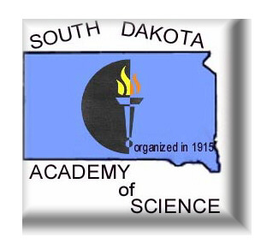

SCHEDULE OF EVENTS

104th Annual Meeting

Thursday, April 11, 2019
Friday, April 12, 2019
Saturday, April 13, 2019

Arrowwood and Bridges Conference Center
Oacoma, SD

Hosted by
Mount Marty College

Local Arrangements Chairpersons
Dr. Chun Wu
Dr. Timothy Rice

Program Printed by Minuteman Press, Sioux Falls, SD
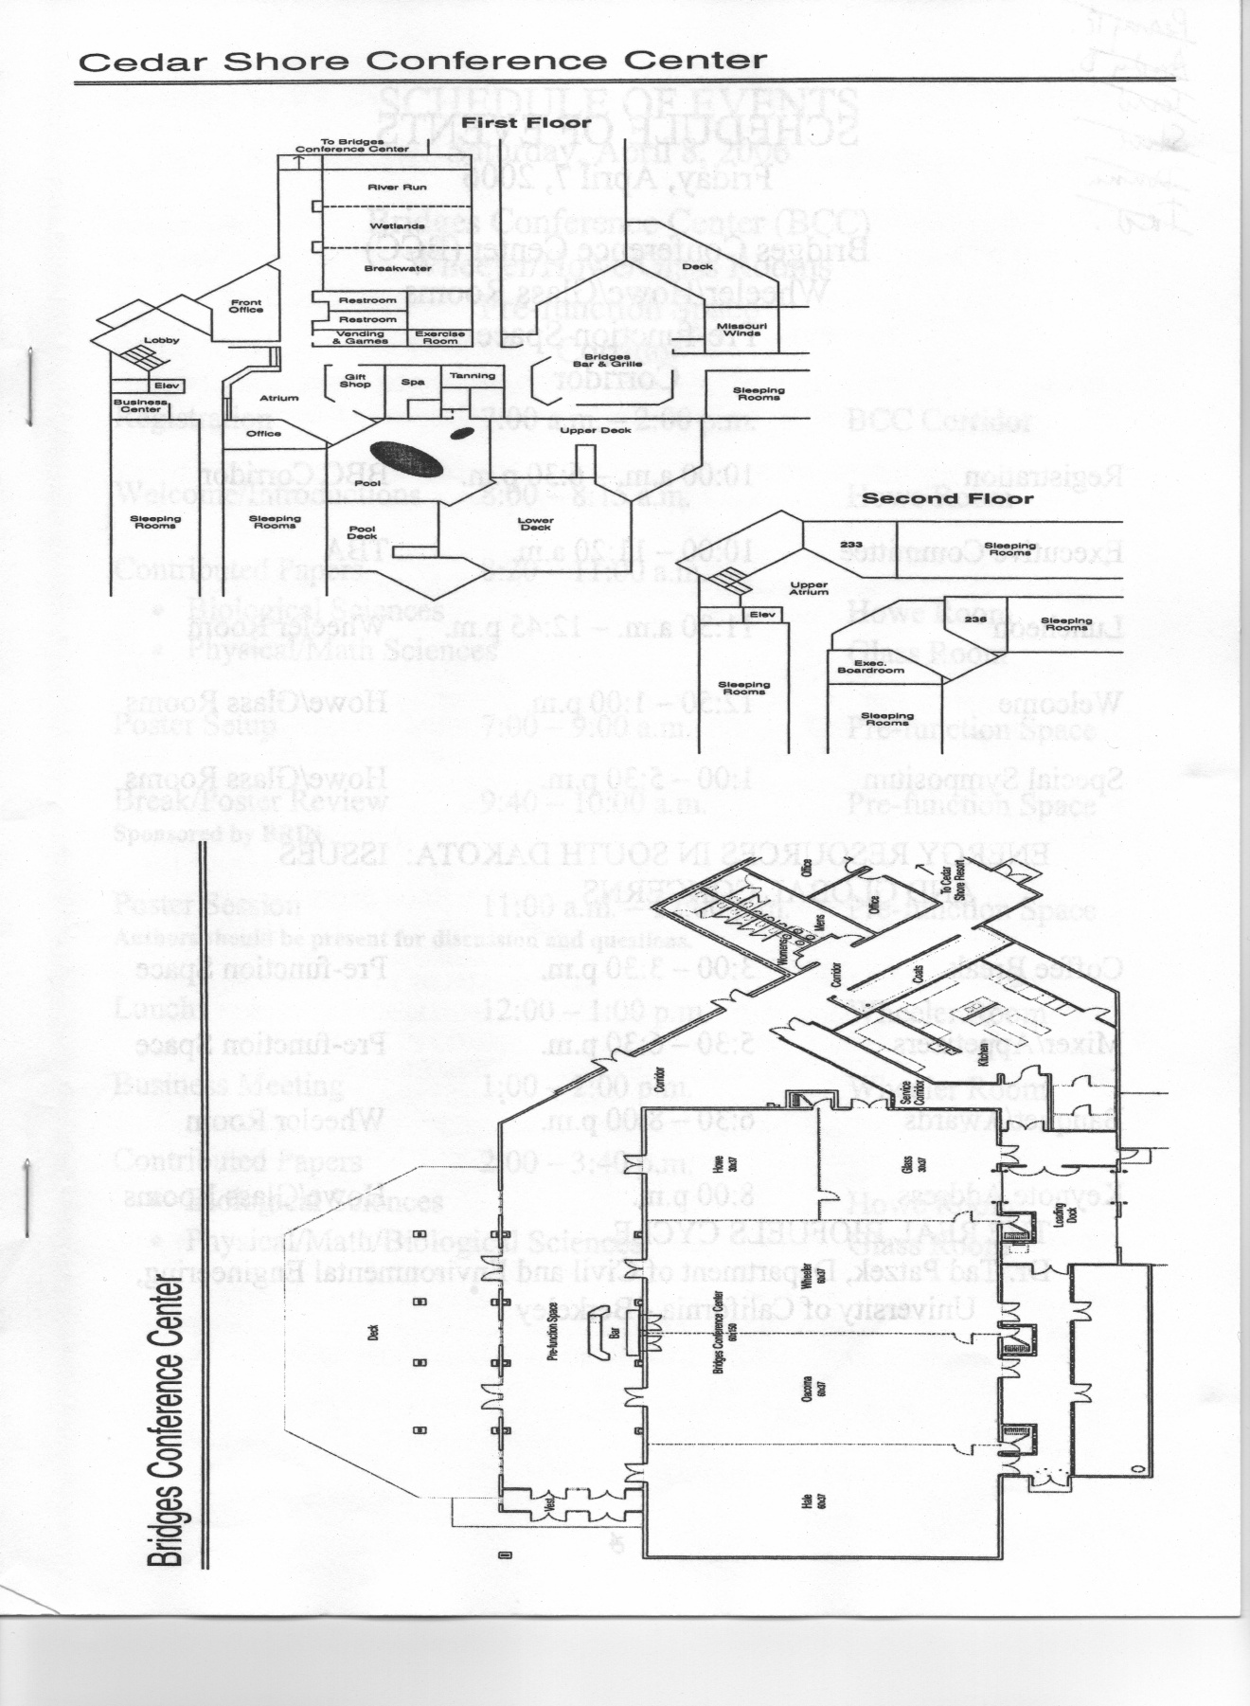

---------------------------------------SCHEDULE OF EVENTS----------------------------------Thursday, April 11, 2019

Executive Council Dinner/Meeting 5:00-7:00 PM Breakwater

---------------------------------------SCHEDULE OF EVENTS----------------------------------
Friday, April 12, 2019

Cedar Shore Resort and Bridges Conference Center
Wheeler/Oacoma Rooms
Pre-function Space/ Corridor

Registration 8:00 AM – 5:00 PM Corridor

Fellows Symposium 9:00 AM – Noon Oacoma

Fellows Luncheon Noon Missouri Winds

Drug Design Symposium 1:00 PM—4:00 PM Oacoma

Mixer 4:15 PM—5:30 PM Pre-function Space

Banquet/Awards 5:30 PM – 6:45 PM Wheeler

Keynote Address 7:00 PM Wheeler

Keynote Address

“Rational Drug Design”

Dr. Debra Dunaway-Mariano
Emerita Professor of Biochemistry
University of New Mexico

--------------------Friday Morning, April 12, 2019-----------------------

SYMPOSIUM I. FELLOWS OF THE ACADEMY
Moderator: Nels Granholm
9:00 am – 11:30 am Oacoma

Name of presenter is underlined and boldface

9:00—Welcome and Introduction

9:15—"Are our declining efforts to include more lectures and reading assignments relevant to the archives of historical contributions of former authors, educators, scientists, conservationists, etc. resulting in numerous college/university graduates that are lacking in historical knowledge and the means of conveying it forward to future generations of students, citizens, and educators?” Kenneth F. Higgins, David C. Parris, Lora B. Perkins, and Lila M. Morris (10-04)

Ken’s presentation will be followed by a discussion of the themes he presents and then a discussion of the following questions: Shall we have a 2020 Fellows Symposium? If so, what shall be its nature? What does it mean to be a Fellow of the Academy? Should it be more than a celebration of past contributions to the Academy?

Noon—Fellows Luncheon in Missouri Winds (all Fellows of the Academy are invited to a luncheon hosted by the staff of the Proceedings)

.

----------------------Friday Afternoon, April 12, 2019-----------------------

SYMPOSIUM II. DRUG DEVELOPMENT anD DESIGN
Moderator: Chun Wu.
1:00 pm – 4:00 pm Oacoma

Name of presenter is underlined and boldface

1:00 Welcome and Introduction.

1:15-1:45 In Vivo Antibacterial Analysis of MRSA Acetate Kinase Inhibitors. Chris Wixon^{UG}, Debra Bevis, Robert Kilkuskie, and Chun Wu (19-10)

1:45-2:15 SEARCHING FOR THE MECHANISM OF ACTION OF A TRADITIONAL CHINESE MEDICINE USED IN THE TREATMENT OF ENDOMETRIOSIS. Kathleen M. Eyster, Donis D. Drappeau, and Chun Wu (19-42)

2:15-2:45 investigation of nanostructured metal-organic supercontainers as a new therapeutic approach to treating Drug Addiction. Parvathi Jampani, Marie A Severson, Lisa M. McFadden, and Z. Rick Wang (19-45)

2:45-3:15 Applying Reaction Kinetics and the Lambert W(x) to Measure the Antiproliferation Effects of Glucosinolates Against Human MCF-7 Cells. Jared R. Mays (19-46)

3:15 Wrap Up

4:30 MIXER--Pre-function Space
5:30 Banquet/Awards--Wheeler
7:00 Keynote Address--Wheeler

SCHEDULE OF EVENTS
Saturday April 13, 2019

Registration 8:00 am – 11:00 am Corridor
Contributed Papers 8:00 am – 10:30 am
- Session A. Biological Sciences Glass
- Session B. Biological Sciences Breakwater
- Session C. Physical Sciences Howe
Poster Setup 8:00 am – 10:30 am Corridor & Pre-function Space

Poster Judging Session 10:30 am – 12:30 pm Corridor &Pre-function Space
(Authors should be present at their posters for discussion)
Luncheon/Business Meeting 12:30 – 2:30 pm Wheeler

------------------------------Saturday Morning, April 13, 2018-------------------

CONTRIBUTED PAPERS
Session A. Biological Sciences
8:00 am-10:30 am Glass

Name of presenter is underlined and boldface

8:00-8:15 GEOCHRONOLOGY AND PRELIMINARY PALEONTOLOGY OF THE PAISLEY FISH LOCALITY, SUMMER LAKE BASIN, NORTHERN LAKE COUNTY, OREGON. James E. Martin, Jennifer E. Hargrave, and Andrew Whisnant (19-08)

8:15-8:30 DERIVED DENTAL CHARACTERS DISCOVERED IN AN ORELLAN CANID (BOROPHAGINAE: PHLAOCYONINI) AND THE EARLY DIVERSIFICATION OF DOGS PROXIMAL TO THE EOCENE-OLIGOCENE TRANSITION. Ed Welsh and Jason Moore (19-36)

8:30-8:45 SPLIT CARINAE ON A SPECMEN OF FALSE SABER-TOOTH CAT (CARNIVORA: NIMRAVIDAE) AND THE IMPLICATIONS FOR HOMOLOGOUS TOOTH ABNORMALITY FORMATION IN MAMMALS AND THEROPOD DINOSAURS. Ed Welsh, Clint A. Boyd, and Kurt Spearing (19-51)

8:45-9:00 The Changing Status of Winter Passerines in South Dakota: Are Recent Records Associated with Warmer Winters? David Swanson (19-05)

9:00-9:15 The Dakota skipper (Hesperia dacotae Skinner) on the Prairie Coteau. Kendal A. Davis and Paul J. Johnson (19-12)

9:15-9:30 ACTIVITY OF LATE INSTAR LARVAE OF THE GIANT EUCOSMA (EUCOSMA GIGANTEANA (RILEY)) IN EASTERN SOUTH DAKOTA. Paul J. Johnson, Arvid Boe, and Abigail Martens (19-18)

9:30-9:45 THE DIVERSITY OF APHID PARASITOIDS (HYMENOPTERA: BRACONIDAE: APHIDIINAE) IN SOYBEAN FIELDS OF EASTERN SOUTH DAKOTA. Abigail P. Martens, Paul J. Johnson, Arvid Boe, and Adam Varenhorst (19-15)

9:45-10:00 Age, Succession Planning & Wildlife Values of UPPER MIDWEST Landowners. Larry M. Gigliotti and Lily A. Sweikert (19-06)

10:00-10:15 From Pasture to Forest: Secondary Succession in Southwestern Michigan. Robert Tatina (19-02)

10:30-12:30--Poster Session—Corridor and Pre-function space
12:30—Luncheon & Business Meeting--Wheeler

CONTRIBUTED PAPERS
Session B: Biological Sciences
8:00 am-10:30 am Breakwater
Name of presenter is underlined and boldface

8:00-8:15 SEED SET AND SEED-INSECT INTERACTIONS IN NATURAL AND CULTIVATED POPULATIONS OF PURPLE PRAIRIE CLOVER. Arvid Boe, Paul J. Johnson, and Abigail P. Martens (19-26)

8:15-8:30 OAK LAKE FIELD STATION: AN INVITATION AND OVERVIEW OF THE LAST 30 YEARS. Nels H. Troelstrup, Jr. (19-27)

8:30-8:45 A HISTORICAL SYNOPSIS OF WHAT’S BEEN HAPPENING IN THE NORTH AMERICAN “DUCK FACTORY”! Kenneth F. Higgins, David C Parris, and Lora B. Perkins (19-16)

8:45-9:00 IDENTIFYING ROCK BASS (Ambloplites rupestris) BEHAVIOR TO MODIFIED FYKE NETS THROUGH VIDEO. Derek Hartl and Greg Simpson (19-03)

9:00-9:15 PROMOTING VEGETATION HETEROGENEITY WITH ALTERNATIVE GRAZING STRATEGIES TO IMPROVE ECOSYSTEM SERVICES. Luke Zilverberg, Jameson Brennan, Kassidy Weathers, Patricia Johnson, and Lan Xu (19-50) JUDGE

9:15-9:30 Effects of Heavy Winter Patch Grazing and Wildfire on Small Mammals. Kaitlyn Cihoski^{UG}, Lan Xu, and Eric Michel (19-13) JUDGE

9:30-9:45 Effects of Genetic Variation and Nitrogen Addition on Bud and Tiller Production in Switchgrass. David G. Flanery^{UG}, Arvid Boe, and Lan Xu (19-30) JUDGE

9:45-10:00 Proposed Project: Describing plant-pollinator networks nestled within the Eastern Coteau’s agricultural landscape. Isabela Vilella-Arnizaut and Charles Fenster (19-40) JUDGE

10:00-10:15 AGE, GROWTH AND MORTALITY OF PYGANODON GRANDIS IN RELATION TO LAKE TROPHIC STATE. K.M. Wollman and N.H. Troelstrup, Jr. (19-43) JUDGE

10:15-10:30 WATER QUALITY ANALYSIS OF LAKE PETÉN ITZÁ, GUATEMALA AND EXPLORING THREAT OF A MAJOR FISH KILL SHOULD THIS DEEP TROPICAL LAKE EXPERIENCE TURNOVER. C. L. Iversrud^{UG}, C. N. Spencer, and G. O. Constanza (19-41) JUDGE

10:30-12:30--Poster Session—Corridor & Pre-function Space
12:30—Luncheon & Business Meeting--Wheeler

CONTRIBUTED PAPERS
Session C: Physical Sciences
8:00 am-10:00 am Howe

Name of presenter is underlined and boldface

8:00-8:15 FCPs Search with CDMSlite Run2a. Sudip Poudel on behalf of SuperCDMS collaboration (19-20) JUDGE

8:15-8:30 Synthesis, Preparation, and Thermoelectric Properties of Synthetic Mineral Sulfides. Jace Waybright^{UG}, Gabin Guélou, Naohito Tsujii, and Takao Mori (19-17) JUDGE

8:30-8:45 Surface modification approaches for enhancing bio-electrocatalytic performance in MFC and biocorrosion applications. Jamil Islam, Jawahar Kalimuthu, Govinda Chilkoor, Rajesh Sani, and Venkataramana Gadhamshetty (19-31) JUDGE

8:45-9:00 MINER: Utilizing Low Threshold Cryogenic Detectors and Movable Reactor Core to Look for Neutrinos that Defy the Standard Model. Joseph Mammo on behalf of the MINER Collaboration (19-29) JUDGE

9:00-9:15 DATA VISIALIZATION OF SuperCDMS EXPERIMENT. Ruslan B. Podviianiuk on behalf of SuperCDMS collaboration (19-19)

9:15-9:30 Sanford Underground Research Facility. Markus Horn (19-21)

9:30-9:45 Hallo Manganese oxide as an alternative cathodic catalyst for enhanced oxygen reduction in microbial fuel cell. Bhuvan Vemuri, Jamil Islam, Dr. James Hoefelmeyer, and Venkataramana Gadhamshetty (19-52)

9:45-10:00 Biobattery-Supercapacitor Hybrid Devices Powered by Municipal Wastewater. Sambhu Sapkota, Namita Shrestha, Sushma Priyanka Karanam, Matthew Hummel, Zhengrong Gu, and Venkataramana Gadhamshetty (19-53)

10:30-12:30--Poster Session—Corridor & Pre-function Space
12:30—Luncheon & Business Meeting--Wheeler

POSTER JUDGING SESSION

10:30 am-12:30 Corridor & Pre-function Space

Name of presenter is underlined & bold.

Species differences drive bat activity in urban versus forested plots. Andy A. Sechrist and C.L. Chambers (19-07) JUDGE

GREENHOUSE GAS EMISSIONS OF A SALINE SOIL AND NON-SALINE SOIL UNDER VEGETATION. Douglas Fiedler, David Clay, Stephanie Bruggeman, Cheryl Reese, Samuel Thies, Andrew Engel, Sharon Clay (19-09) JUDGE

Identification and Characterization of Mitogen-Activated Protein Kinase Kinase Kinase (MKKK) Genes in Sunflower (Helianthus annuus L.). S. Neupane, Schweitzer, S.E Schweitzer ^{UG}, S.N. Kaluwahandi ^{UG}, and M.P. Nepal (19-11) JUDGE

Mining Metagenomes for Bioplastics and other useful Bioproducts. Tanvi Govil, Wageesha Sharma, David R. Salem, and Rajesh K. Sani (19-14) JUDGE

QUAKING ASPEN GROWTH RATE WITHIN THE BLACK HILLS, SOUTH DAKOTA. Zach Mergen^{UG} and Daryl E. Mergen (19-22)

Crystal Structure and Magnetism of (NdxCe1-x)YFe15 Alloys. Thomas Ott^{UG}, B. Dahal, Y. Huh, and P. Kharel (19-39) JUDGE

Synthesis and Characterization of a Novel Heusler Alloy: Fe₂MnSn. Abdullahal A. Maruf^{UG}, B. Dahal, Y. Huh, and P. Kharel (19-38) JUDGE

Performance of Clonal Plant Buffalograss After Multiple Disturbances. Luke Zilverberg, Jacob Comer, and Lan Xu (19-37)

Studying physiological and molecular regulation of stomatal density and its relationships to water use efficiency in alfalfa. Surbhi Gupta, Krishna Ghimire, Arvid Boe, and Yajun Wu (19-35) JUDGE

Resistance Genes in Wheat (Triticum aestivum L.) Show Evidence of Tandem Duplication as a Mechanism for Functional Diversification. E.J. Andersen, J.M. Purintun, S. Neupane, and M.P. Nepal (19-34) JUDGE

Spatial Expression of Genes during Hydrotropism in Maize Roots. Yafang Wang, Muyu Gu, Mike Hildreth, and Yajun Wu (19-33)

Improved Wideband Performance Linear Antenna. Thomas P. Montoya and Andrew W. Downs (19-32)

Validation of the Transcriptomic Response of Candida glabrata to Treatment with Thymoquinone. Kelsey D. Wood^{UG}, N. Malik, and C.M. Anderson (19-28) JUDGE

SEASONAL VARIATION IN TRICHOSTRONGYLE EGG SHEDDING IN A BISON HERD FROM EASTERN SOUTH DAKOTA. J.B. McKenzie, AT. Heien^{UG}, P.S. Heliso^{UG}, and M.B. Hildreth (19-25) JUDGE

A COMPUTER MONTE CARLO MODEL OF A SODIUM IODIDE SCINTILLATION DETECTOR TO CALIBRATE DATA OF RADIOACTIVE CONTAMINANTS. W.W. Riley^{UG} and K.J. Keeter (19-24) JUDGE

Impacts of Heavy Winter-Patch Grazing and Wildfire on Arthropod Community Heterogeneity in Mixed-grass Prairie. Alyssa Vachino^{UG} and Lan Xu (19-23) JUDGE

Evaluating Anti-Malarial Activity With N-Methylfluoxetine And Diphenylpropylamines. Dillon Vanetti^{UG} and Dr. John Dixson (19-44) JUDGE

Investigating the Kinetics of Montmorillonite Clay-Catalyzed Conversion of Anthracene to Anthraquinone in the Context of Origins of Life Studies. Hope Juntunen^{UG}, Lucas Leinen^{UG}, Briann K. Pitts^{UG}, Kaytlyn N. Schaefer^{UG}, Scott E. McKay, Samantha M. O’Hanlon, Bethany P. Theiling, Laura M. Barge, Patrick Videau, and Michael O. Gaylor (19-47)

Profiling Volatile Emissions from Sewage Sludge Land-Applied Across Washington State (USA) Using Headspace Sampling with Gas Chromatography-Mass Spectrometry (GC-MS) Determination. Lucas J. Leinen^{UG}, Kaytlyn N. Schaefer^{UG}, Vaille A. Swenson^{UG}, Bailey A. Moody^{UG}, Hope L. Juntunen^{UG}, Scott E. McKay, Silvia Beurmann, Samantha M. O’Hanlon, Richard C. Honour, Robert C. Hale, Patrick Videau, and Michael O. Gaylor (19-48) JUDGE

Profiling Volatile Constituents of Homemade Preserved Foods Prepared in Early 1950s South Dakota (USA) Using Solid-Phase Microextraction (SPME) with Gas Chromatography–Mass Spectrometry (GC-MS) Determination. Lucas J. Leinen^{UG}, Vaille A. Swenson^{UG}, Hope L. Juntunen^{UG}, Scott E. McKay, Samantha M. O’Hanlon, Patrick Videau, and Michael O. Gaylor (19-49) JUDGE

12:30—Luncheon & Business Meeting--Wheeler

South Dakota Academy of Science
2017-2019 Executive Council

President  2017-2019 | Vicki Geiser, and Freeman Regional Health Services, Foundation  925-2142, Vicki.Geiser@freemanregional.com
Vice President  2017-2019 | Tim Mullican, DWU, Biology  995-2715, timullic@dwu.edu
Past President  2017-2019 | George Mwangi, USF, Chemistry  575-2069, George.mwangi@usiouxfalls.edu
Secretary | Donna Hazelwood, DSU, Biology, (retired)  256-5187, donna.hazelwood@dsu.edu
Treasurer | Jeffrey Palmer, DSU, Mathematics  256-5190, Jeff.Palmer@dsu.edu
Proceedings Editor | Robert Tatina, DWU, Biology (retired)  269-426-3744 rotatina@dwu.edu,
Chair of Fellows Nominations Committee | Brian Patrick, DWU. Biology  995-2712, brpatric@dwu.edu
Chair of Membership Committee | Paula Mazzer**. DWU, Chemistry.  995-2899, pamazzer@dwu.edu
Publicity | Thomas Montoya*, SDSM&T, EE, CENG  394-2459, Thomas.Montoya@sdsmt.edu
Publicity | Steve Matzner, AU, Biology  274-4821 steven.matzner@augie.edu
Publicity | Paula Mazzer. DWU, Chemistry.  995-2899, pamazzer@dwu.edu
Publicity | Dave Bergmann, BHSU, Biology,  652-2420, DaveBergmann@bhsu.edu
Publicity | Robert Tatina, DWU, Biology (retired)  269-426-3744; rotatina@dwu.edu,
Publicity | Chun Wu, MMC, Chemistry,  668-1381, cwu@mtmc.edu
Webmaster | Tim Mullican, DWU, Biology  995-2715, timullic@dwu.edu
Member-at-Large  2017-2019 | Mark Gabel, BHSU, Biology (retired)  642-6251, Mark.Gabel@bhsu.edu
Member-at-Large  2017-2019 | Brian Patrick, DWU. Biology  995-2712, brpatric@dwu.edu
Member-at-Large  2017-2019 | Adam Sturlaugson, USF, Chemistry  331-6757, Adam.Sturlaugson@usiouxfalls.edu
Member-at-Large  2016-2018 | Arvid Boe, SDSU, Plant Science  688-4759, Arvid.Boe@sdstate.edu
Member-at-Large  2016-2018 | Xu Lan, SDSU, Department of Natural Resource Management  688-4564. Lan.Xu@sdstate.edu
Member-at-Large  2016-2018 | Matt Miller, SDSU, Education  688-6274, Matt.Miller@sdstate.edu
Member-at-Large  2016-2018 | Alyssa Kiesow, NSU, Biology  626-7707, Alyssa.Kiesow@northern.edu
Member-at-Large  2016-2018 | Paul Johnson, SDSU, Entomology  688-4438, paul.johnson@sdstate.edu
*elected VP for 2019-2021; **elected VP for 2021-2023

Upcoming Meeting Locations

2020 Northern State University, Aberdeen, SD. Contact person Alyssa Kiesow
2021 Black Hills State University, Spearfish, SD
Notes

